QUEEN ANNE / HILLSBORO
VOLUNTEER FIRE COMPANY
PRIMARY PROVIDER
ORIENTATION WORKBOOK
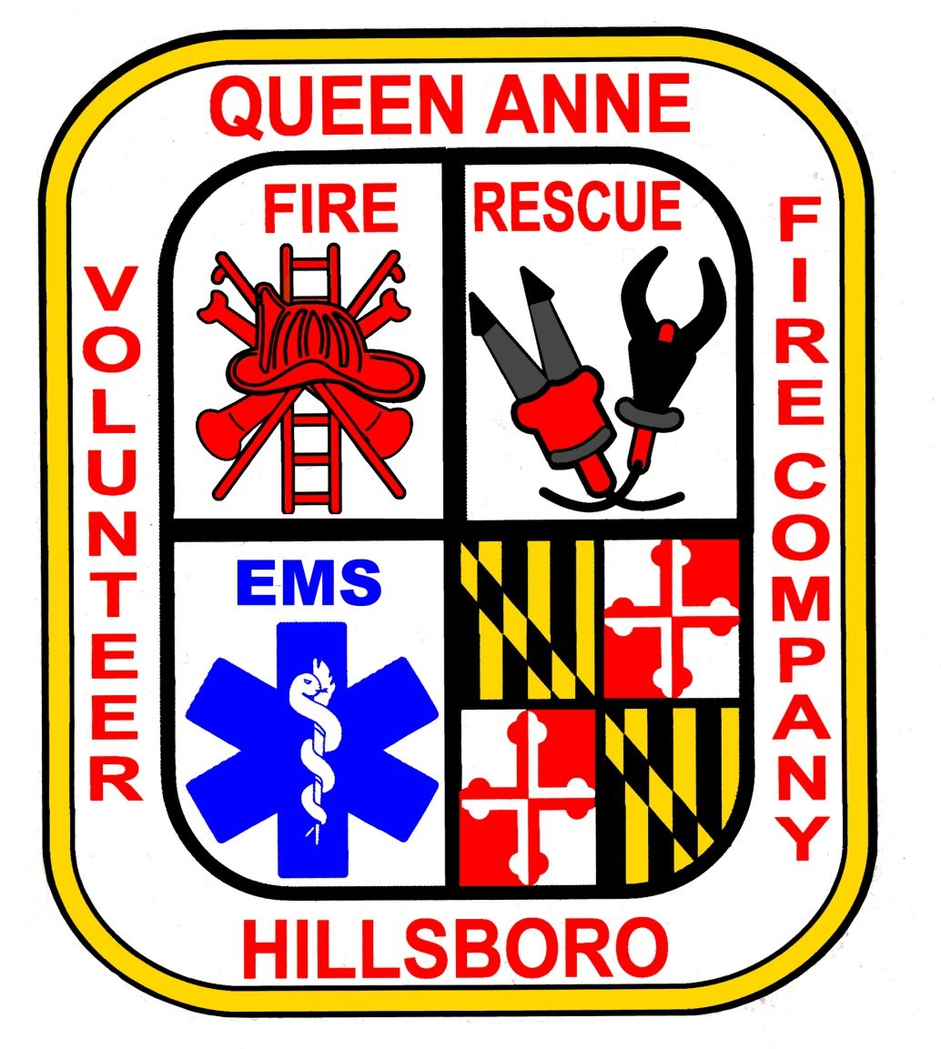

PURPOSE

The orientation workbook is designed to provide a newly certified provider with the foundation necessary to achieve clearance to function as a primary care provider, while maintaining the flexibility for experienced providers to become oriented with company and jurisdictional procedures and standards.

To prepare the provider to function independently in an emergency situation, while maintaining quality patient care and scene safety in order to provide the best possible patient outcome.

SCOPE

The workbook is to be completed by all providers wishing to achieve clearance to function as a primary care provider with the Queen Anne / Hillsboro Volunteer Fire Company.

MANDATORY PROGRAM REQUIREMENTS

Newly certified providers will be required to complete the entire workbook, where experienced providers can challenge phase 4. If the experienced provider cannot pass phase 4 they will be required to complete the entire workbook.

Newly certified providers will be assigned a primary preceptor that will be responsible for the oversight of the student’s progress and assist the student in the completion of paperwork, documentation, and correspondence. Newly certified providers may ride with other station preceptors, but primary responsibility lies with the assigned preceptor.

The Workbook consists of 4 phases, each of which has individual requirements that must be completed. All phase requirements must be completed prior to moving to the next phase.

All 4 phases must be completed within 6 months from date started. If the 6 month time period lapses then the provider must start the program over from the start. If there are extenuating circumstances as to why the workbook could not be completed within the six month period the provider may request a 3 month extension from the EMS Captain detailing the circumstance. At the EMS Captains discretion a 3 month extension may be granted one time only. If at the end of the extension the workbook is not complete the provider must start from the beginning again.

The workbook is broken into 4 clinical phases that have no maximum number of hours or call requirements. The phases are defined as follows:

Phase 1: Orientation Phase

The goal of this phase is for the provider to become oriented to the EMS system. The provider will participate in the care and assessment of the patient as directed by the preceptor, which will include but not limited to patient care skills, vital signs, and location of equipment.

Phase 2: Practice Phase

In this phase the student will be the Basic Life Support team leader in conjunction with the preceptor. The provider will direct all team members to perform or perform themselves all Basic Life Support skills, assessments, or interventions.

Precepting Phase

In this phase the provider will be evaluated on their performance, skills, assessments, and interventions on calls. The provider will handle all calls as if the evaluator was not present.

Check Phase

In this phase the provider will be evaluated by the highest EMS officer or their designee.

This evaluation can either be done either on a call or scenario. The decision of the officer can either be to clear the provider as a “Primary Provider” or send the provider back to phase 3 with specific issues needing to be met prior to re-evaluation in phase 4.

Phase Requirements

Phase 1 will consist of a minimum 4 hours and with at least 1 patient encounter.

Consistently demonstrates professional behavior.

Demonstrates initiative and interest in all learning activities.

Assist with all duty assignments including housekeeping, vehicle cleaning, and equipment checks.

Be familiar with equipment, supplies, and participate in pre-shift check.

Accept constructive feedback in a positive manner.

Bring the workbook and every shift.

Phase 1 Tasks

Review the location of medical, safety, and communications equipment on the units.

Review how to use the radio system to summons help in an emergency.

Review the use of the radio system to notify the hospital with patient information.

Phase 1 Skill Performance

Demonstrates proper use of the ambulance stretcher.

Successfully obtain vital signs.

Provides safe, careful, and patient oriented care in all patient encounters.

Complete comprehensive written patient care reports on every patient encounter at the completion of each call.

Phase 2 will consist of a minimum of 4 hours and at least 5 patient encounters, 2 of which must be ALS including 1 priority 1 medical.

Consistently demonstrates professional behavior.

Demonstrates initiative and interest in all learning activities.

Assist with all duty assignments including housekeeping, vehicle cleaning, and equipment checks.

Be familiar with equipment, supplies, and participate in pre-shift check.

Accept constructive feedback in a positive manner.

Bring the workbook and every shift.

Phase 2 Tasks

Learn how to lead calls whether a patient is critical or not, and will be treated with Basic Life Support skills.

Learn how to participate as a team member on calls whether a patient is critical or not, and will be treated with both Advanced and Basic Life Support skills.

Conduct patient histories, interviews, and physical exams.

Perform notifications to receiving hospitals with patient information and request for additional orders (if needed).

State and recite all indications, dosages, administration route, contra-indications, and side effects of any medication that a Maryland EMT-B is responsible to remember.

Be able to demonstrate any skill taught in the EMT-B curriculum.

Phase 2 Skill Performance

Successfully perform Basic Life Support procedures as permitted by the preceptor.

Provides safe, careful, and patient oriented care in all patient encounters.

Complete comprehensive written patient care reports on every patient encounter at the completion of each call.

Phase 3 will consist of a minimum completion of 5 patient encounters in the following categories.

2 Medical Calls, priority 1 or 2

1 Trauma Call any priority

2 Additional Basic Life Support Calls with consult. Must not be ALS calls.

Phase 3 Objectives

The provider will be able to function autonomously. The Evaluator will not assist the provider in any way. The provider will function as if the evaluator is not there. Evaluators are not available to assist, perform skills, or assessments, unless the lack of such will cause a lack of patient care in which case the call will not be counted toward the minimum phase 3 calls.

Phase 4 Final Evaluation

Will consist of the provider being evaluated by the highest ranking EMS officer or designee. The evaluation will be on a patient call or scenario or both per the discretion of the evaluator. At least 3 skills will be evaluated, a patient assessment will be done, and a medical consult will be done.

On successful completion of evaluation the provider workbook will be checked for completion of documentation and provider will be cleared by the final evaluator as a primary provider.

The provider’s completed workbook will be kept in the provider’s file for review by jurisdictional agency.

EXPERIENCED PROVIDER PHASE 4

Experienced providers are defined as any certified EMT-B that is cleared as a primary provider in any jurisdiction in Maryland. Experienced providers may elect to begin the process at the beginning of the workbook or at a modified phase 4.

The experienced provider will be required to complete a minimum of 3 patient contact calls with an assigned preceptor. The calls will consist of the following:

1 medical call, priority 1 or 2

1 trauma call, priority 1 or 2

1 BLS only call with consult

The experienced provider will the either run a patient encounter call with the highest ranking EMS officer or designee. At the discretion of the highest ranking EMS officer a scenario testing patient assessment skills, vital sign obtaining, and 3 skills can be used as the final evaluation in lieu of the call.

On successful completion of evaluation the provider workbook will be checked for completion of documentation and provider will be cleared by the final evaluator as a primary provider.

On completion of the experienced provider phase 4 the workbook will be kept in the provider’s file for review by the jurisdictional agency.

If at the discretion of the highest ranking EMS officer it is deemed the experienced provider need more orientation then the provider will begin at phase 1.

PRECEPTOR

A preceptor is an EMT-B that has been cleared as a primary provider for at least one year.

Preceptors are chosen by the highest ranking EMS officer after application to be a preceptor. Preceptor will be evaluated on a yearly basis by the EMS officers for continuation as a preceptor.

EVALUATOR

An evaluator is an EMT-B that has been cleared as a primary provider for at least two years.

Evaluators are chosen by the highest ranking EMS officer after application to be a preceptor. Evaluator will be evaluated on a yearly basis by the EMS officers for continuation as an Evaluator.

