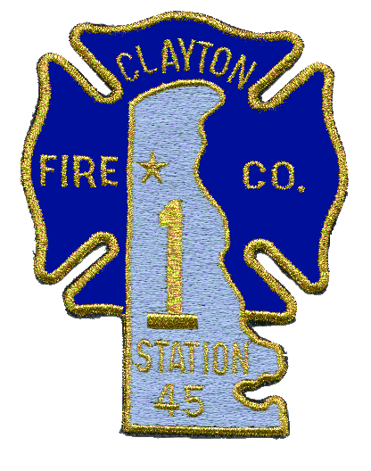
Post Office Box 1050 Fire Calls: 911
Clayton, Delaware 19938 All Others: 302 653-7317
Fax: 302 653-3712

Clayton Fire Company, No. 1, Inc.

CLASSES FOR UNIFORM USE

CLASS A UNIFORM Full parade uniform; consisting of all parts of the uniform, black socks, black high gloss dress shoes, braid, black belt, parade hat
and white gloves. Company issued award bars will be worn directly beneath
the company badge on the left breast. Class A uniform will be worn at all funerals, the state fireman’s conference parade and any formal event deemed necessary by
Chief of the Company.

CLASS B UNIFORM Summer parade uniform; consisting of uniform pants, black high gloss dress shoes, black socks, black belt, white uniform shirt. Badge, braid, company issued award bars can be removed from dress coat and place in proper place on the white shirt, parade hat and white gloves when necessary. Class B uniform will be worn from May 1 thru Sept 30th each year, except for formal events or when deemed so by Chief of the Company.

CLASS C UNIFORM Stand by uniform; consisting of navy blue pants or BDU’s, Black or Navy blue belt, tan button up short sleeve stand by shirt, or Blue 5-11 station shirt, or appropriate blue polo shirt with company maltese patch on left breast. Black or navy blue socks, black boots, shoes or sneakers. Class C uniforms will be worn on special stand by’s funerals, other companies banquets, and when attending open houses’.

CLASS D UNIFORM Stand by uniform; consisting of blue pants or BDU’s or blue shorts or BDU shorts that come to just above the knee, black or navy blue socks, black boots, shoes or sneaker, navy blue long or short sleeve shirts with fire company Maltese cross on left breast and appropriate fire company lettering across rear of shirt. Class C uniform can be worn at discretion of the officer in charge of the crew for the event, such examples would be; stand by’s at state fair, July 4th events, stand by’s at other stations non formal events, football game stand by’s. It may be worn anytime at any event when deemed appropriate by the Chief of the Company.

CLASS E UNIFORM Optional uniform for Serving dinners, tending bar or working other fund raising functions; consisting of dress pants, khaki pants, company polo shirt or tan or blue button up shirt, dark belt, dark socks and appropriate shoes. Class E uniform will be worn at the discretion of the administrative or fire line officer in charge.

revised 3/1/11

Organized 1891

