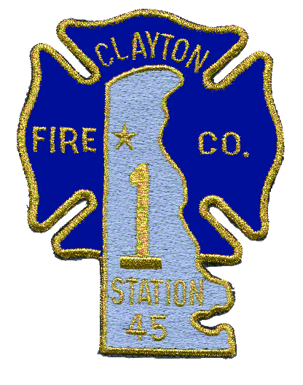
Post Office Box 1050 Fire Calls: 911
Clayton, Delaware 19938 All Others: 302 653-7317
Fax: 302 653-3712

Clayton Fire Company, No. 1, Inc.
FIRE PREVENTION QUEENS APPLICATIONS

AGE GROUPS; (AGE THE CANIDATE WILL BE AS OF OCTOBER 1 OF THIS YEAR)
LITTLE MISS 4 TO 6 YEARS OLD
PRE-TEEN 7 TO 10 YEARS OLD
JR. MISS 11 TO 14 YEARS OLD
MISS 15 TO 17 YEARS OLD

MEMBERS NAME: ________________________________

MEMBERS SIGNATURE: ___________________________

CANIDATES RELATIONSHIP TO MEMBER: ___________

CANIDATES NAME: ________________________________

CANIDATES DATE OF BIRTH: ______________________

CANIDATES AGE: ________

DATE APPLICATION FILLED OUT: _________________

(ONCE COMPLETED PLEASE TURN INTO FIRE CHIEF)
Organized 1891

